1

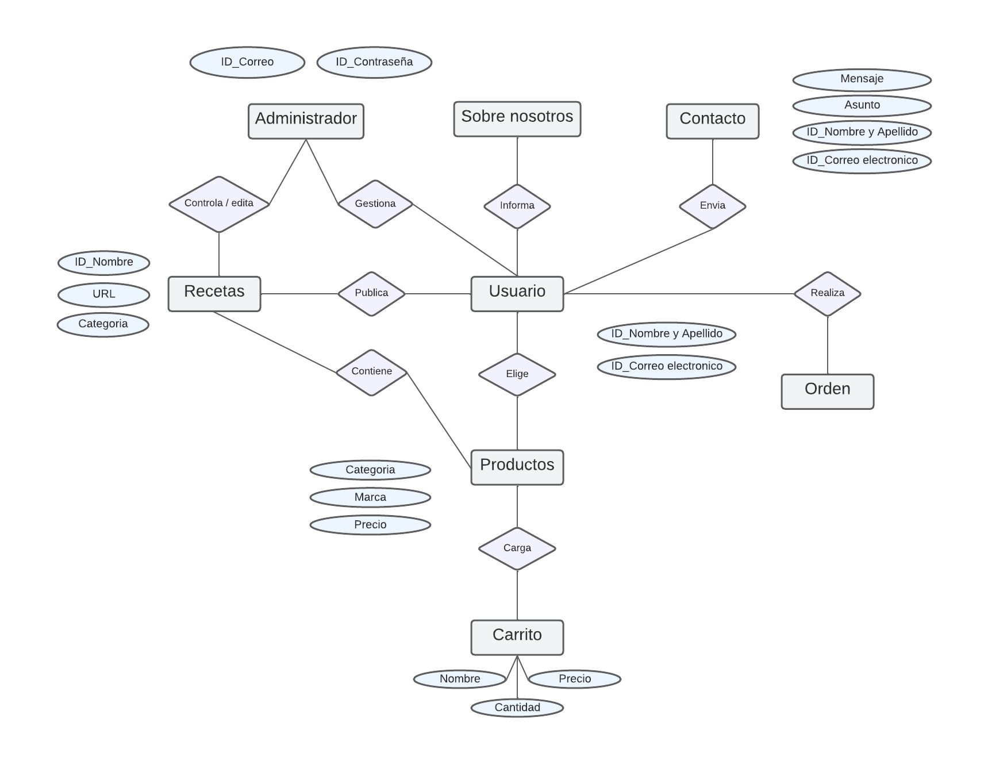

1

N

N

1

1

N

1

1

1

1

1

1

1

1

1

1

1

1

1

1

N

1

1

N

N

N

1